Katana FxFloorBoard Help

Katana FxFloorBoard is a midi patch editor software made to assist with getting the most from your Katana modelling amplifier.

This software provides a graphical layout of your Katana’s internal settings and virtual pedal board, and allows you to access settings not available from the front panel. FxFloorBoard also provides access to “hidden” extra features not available from the ‘official’ Boss editor.

The extra features include 23 extra (“sneaky”) preamps and 5 custom preamps parameters, extra effects hidden in MOD, FX, and Delay 1 & 2, and Custom Booster drives.

This editor software also allows use of more effects blocks, where the Katana allows a choice of either “Booster or MOD”, “Delay 1 or FX”, and “Delay 2 or Reverb”. You now use all of these at one time, switching them independently.

The signal chain typically has limited choice of arrangement, but with FxFloorBoard, the effects in the signal chain can be placed in any preferred order.

Since the Katana is a subset of the Boss GT series of Multi-effects, patch files can be Opened from the file menu and translated for the Katana, these include patches for the GT-100, GT-001, GT-10, GT10B, GT-8, GT-6B, and the ME-80. Patches can be in \*.tsl (Tone Studio Library), \*.syx, or \*.mid file formats.  Patches (a snapshot of a channels settings) can also be saved in \*.tsl format to use with Tone Studio, and exported in native \*.syx format too.

Katana FxFloorBoard also has a feature called “Patch Loader”, which allows your computer/tablet/laptop to be used, along with a Midi Foot Controller, as a 128 channel extension to your Katana. Giving you 128 instant access channels recalled from you midi controller. The extra channels make use of 16 “Assigns” functions, giving programmable control over any of the Katana parameters.

First time use

Before using Katana FxFloorBoard, a USB driver may be required (depending on your operating system) to be downloaded and installed, the Katana USB driver can be downloaded from the Boss website, and installed as recommended by the manufactures instruction.

Once the driver is installed (if required), plug in the Katana USB port to your computer, then start FxFloorBoard editor software.

The Katana midi/USB port will be required to be selected in the FxFloorBoard, by opening from the editor menu “Preferences”, and select “Katana” if using the Katana USB port directly, or other Midi device if an alternative USB/Midi connection is used to the Katana. Select O.K. to accept the device, this will now be saved to a preferences file and the connection will usually be ready next time the editor is started.

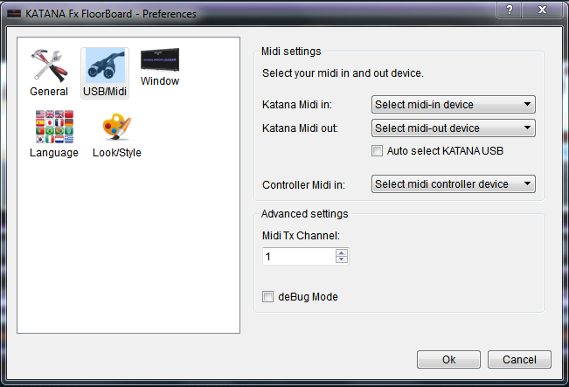

After the USB/Midi device is selected and the dialog window is closed, the editor will require the “CONNECT” button to be activated, which is found top/centre of the FxFloorBoard editor main screen. Press the “Connect” button and the button will flash green, and if the connection is successful, will remain lit green. The editor main screen will now be populated with the current Katana amp settings, and the left-side panel “Patch-Tree” will populate the channel names.

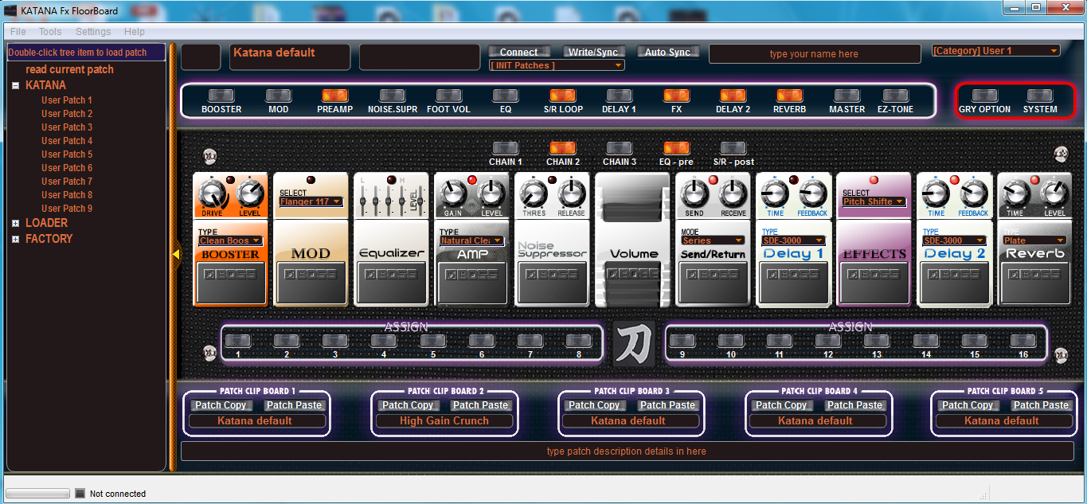

The Main Screen Layout

After the midi connection has been established and the editor is “Connected”, the editor is ready to use.

The left panel contains the “Patch Tree” list of Katana channels, and Patch Loader channels. A “single mouse click” on a Katana Channel will change the Amp’s channel to that selected option, and as you play your guitar, the sound of that selected channel will be heard.

To load a Katana channel into the editor, in the left panel “Patch Tree” a mouse “double click” will select that channel and request the Katana to send the channel data into the editor, which the settings will then be displayed.